Membership in our multi-level association keeps you connected with opportunities to stay on the fast track and maximize your career advancement and personal growth.

Our continuing legal education, high ethical standards, and leadership opportunities are qualities employers greatly value. This can lead to promotions and higher salaries.

Our legal education meetings are a great way to stay connected with current trends in law and technology, tips on professionalism and leadership, guidance for students, and feature speakers covering all aspects of the law.

Our state (www.nalsofmichigan.org) and national (www.nals.org) web sites bring you up-to-date information on current seminars and events, and provide hyperlinks to other legal sites. You can also find NALS on Facebook, Twitter, and Linkedin.

Benefits of Membership

Continuing Legal Education

Professional Certification Programs
ALP® basic certification
PLS® advanced certification
Professional Paralegal certification
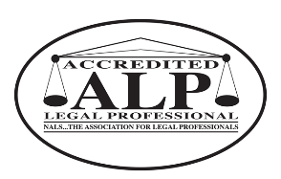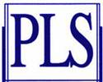

Resource materials
Professional Publications
Nationwide Networking Opportunities

Leadership Enhancement
Scholarships
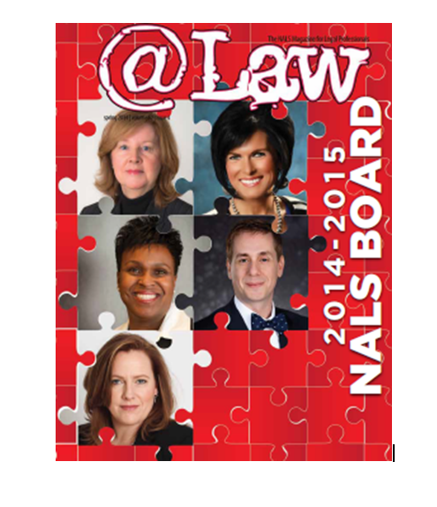

Who Can Join?

Individual members consist of those persons engaged in work of a legal nature who agree to comply with the NALS Code of Ethics and Professional Responsibility.

Legal Secretaries
Bank Trust Employees
Legal Assistants
Attorneys
Law Office Administrators
Title Company Employees
Court Employees
Word Processors
Receptionists
Court Reporters
Persons Employed in the Legal Field
Students in Legal Studies Programs
For information, please contact:
Heidi Hopper, PLS
hhopper@fosterswift.com
517-371-8205
www.nalsoflansing.org

Welcome to
NALS of Lansing!

As a member, opportunities for professional and personal development are plentiful.

NALS is a multi-level organization composed of national, regional, state, and local chapters.

Each level offers top-notch professional growth through seminars, quality publications, and local, state, regional, and national networking.

NALS of Lansing keeps you connected by offering members and non-members the opportunity to sit for three unique certifications dedicated to the legal services profession.

NALS of Lansing was chartered in 1959 by NALS. . . the Association of Legal Professionals, as a local chapter.

In 1961 NALS of Lansing became affiliated with NALS of Michigan (our state chapter). NALS of Michigan is presently composed of 11 local chapters and approximately 300 members state-wide.

Michigan Chapters

Berrien-Cass LSP
NALS of Calhoun County
NALS of Detroit
Genesee ALSP
Grand Traverse Area LP
NALS of Greater Kalamazoo
NALS of Jackson County
NALS of Lansing
NALS of Northern Michigan
NALS of West Michigan

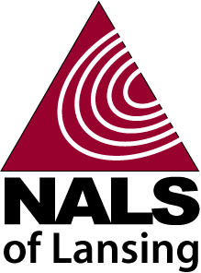

NALS of Lansing is dedicated to enhancing the competencies and contributions of members in the legal services profession.

Serving as an active presence in Lansing’s legal community for over 50 years.

NALS OF LANSING WILL KEEP YOU CONNECTED FOR SUCCESS
www.nalsoflansing.or

